______ are the basic units of inheritance
A. Alleles
B. Genes
C. Gene pool
D. Antigen
ANSWER: B
Alternative form of the same gene in a population at any one time is called ____
A. Genotype
B. Phenotype
C. Locus
D. Alleles
ANSWER: D
The __________is the set of rules used by living cells to translate information encoded within genetic material into proteins.
A. Genotype
B. Phenotype
C. genetic code
D. Alleles
ANSWER: C
A collection of codons is:
A. Genotype
B. Phenotype
C. genetic code
D. Alleles
ANSWER: C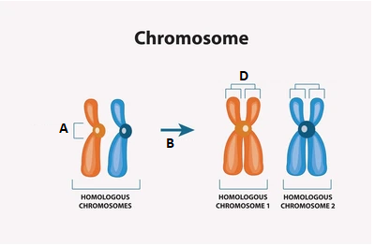
What does A represent in the given diagram?
A. replication
B. sister chromatids
C. chromatids
D. centromere
ANSWER: D
_____ contain codons, which represent each amino acid in protein
A. Genotype
B. Phenotype
C. genetic code
D. Alleles
ANSWER: C
The Mendelian gene is
A. a basic unit of heredity
B. a sequence of nucleotides in DNA
C. location on chromosome
D. None of these
ANSWER: A

What does D represent in the given diagram?
A. replication
B. sister chromatids
C. chromatids
D. centromere
ANSWER: B
the molecular gene is
A. a basic unit of heredity
B. a sequence of nucleotides in DNA
C. location on chromosome
D. None of these
ANSWER: B
Which 3 codons are nonsense codons?
A. UAA,UAU,UUA
B. UGA,UAG,UAA
C. UGG,UGA,UAU
D. UGG,UAA,UAG
ANSWER: B
Protein synthesis starts with this codon:
A. UAG
B. UAA
C. UGA
D. AUG
ANSWER: D
Messenger RNA triplets are called:
A. Sub codon
B. Codon
C. Anticodon
D. De codon
ANSWER: B

What does B represent in the given diagram?
A. replication
B. sister chromatids
C. chromatids
D. centromere
ANSWER: A
____________refers to the instructions contained in a gene that tell a cell how to make a specific protein.
A. Genetic code
B. Gene
C. Allele
D. Loci
ANSWER: A
Methionine is specified by the codon
A. AUG
B. ACU
C. GAU
D. GGG
ANSWER: A

